# 快慢指针：[剑指 Offer 52. 两个链表的第一个公共节点](https://leetcode-cn.com/problems/liang-ge-lian-biao-de-di-yi-ge-gong-gong-jie-dian-lcof/)

## 题目描述：

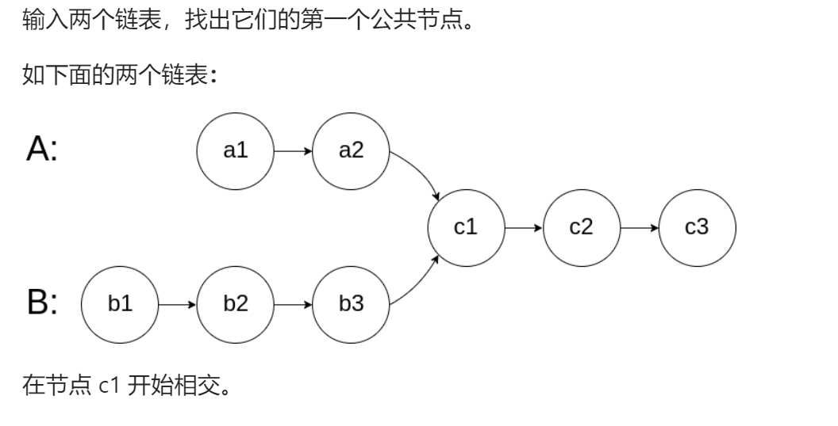

## 快慢指针：

/**  
 * Definition for singly-linked list.  
 * struct ListNode {  
 * int val;  
 * ListNode *next;  
 * ListNode(int x) : val(x), next(NULL) {}  
 * };  
 */  
class Solution {  
public:  
 ListNode *getIntersectionNode(ListNode *headA, ListNode *headB) {  
 //快慢指针  
 ListNode*A=headA,*B=headB;  
 while(A!=B){  
 if(A==nullptr&&B==nullptr)return nullptr;  
 A==nullptr?A=headB:A=A->next;  
 B==nullptr?B=headA:B=B->next;  
 }  
 return A;  
 }  
};